(Approx. 368 words)

First Look at GNOME 40 Desktop
By Cal Esneault, Cajun Clickers Past President and leader of many Open-Source Workshops & SIGs
June 2021 issue, CCCC Computer News
www.clickers.org
office (at) clickers.org

The GNOME 3.x desktop has been a favorite for many Linux distributions. Recently, the GNOME Project updated its toolkit series from the GTK 3.x family to the new GTK 4.x series. New desktops concurrent with this upgrade will now be numbered differently, starting with GNOME 40 as the initial offering. I made a quick comparison of GNOME 3.36 (from Ubuntu 20.04 LTS) to GNOME 40.0 (from Fedora 34).

The GNOME 3.x paradigm emphasized panels and virtual workspaces located on the sides of the screen (see below). Since most computer monitors are wide (for example,16:10 ratio), this gives more working area for the actual application. Because most designs traditionally used horizontal panels (top or bottom), this required some break-in effort, but, overall, it has been effective and accepted by many.
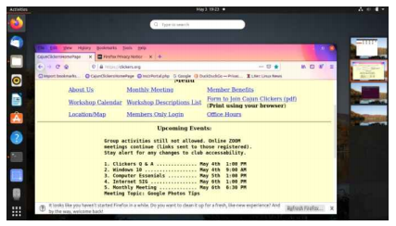
GNOME 40 has reverted to a more horizontal layout (see next column), with launcher panel being centered at the bottom (more like Mac OS design). In “Activity” view, the adjacent workspaces are visible and easily scroll left and right in a very natural motion. There are also workspace thumbnail icons at the top for quick access.

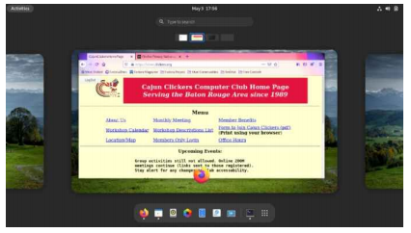

The GNOME 40 program launcher has the same icon grid view as the previous series. However, images for the virtual workspaces are also displayed above the grid (see below).
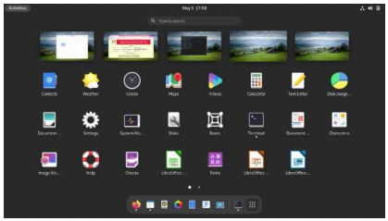
This allows the user to drag an application to any desired workspace to launch it. My previous approach had always been to go to the desired workspace first and then launch the app. This looks like a fast and intuitive solution to a common action.

Of course, this summary does not do justice to a major desktop upgrade, but I wanted to see the new layout for myself since I had heard it was quite different. It looks interesting, and I will eagerly await the adoption of this change when it arrives for one of the distro’s I normally use (note: due to the recency of this desktop, some distro’s have not had time to incorporate it at this time)

